Step 1:
Open elipse

Step 2:
click on file
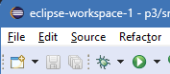

Step 3:
click on import
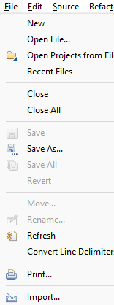

Step 4:
expand the general file
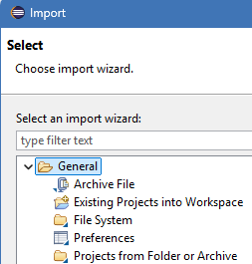

Step 5:
click existing projects into workspaces
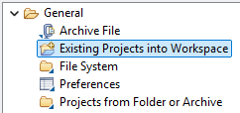

step 6:
next

step 7:
select root directory (jo folder copy krne ke liye rkha hai) browse
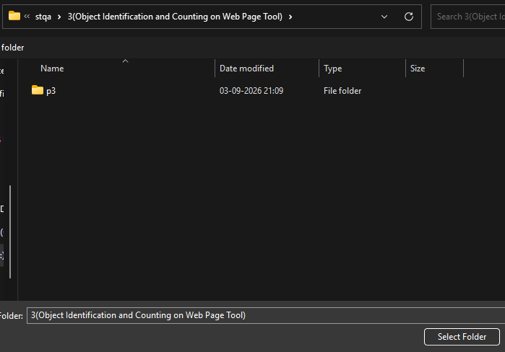

step 8:
now in projects section
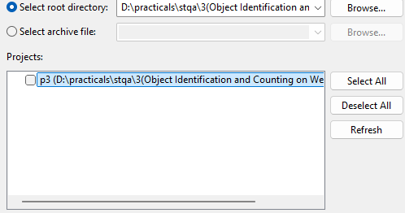

that copied file u can see
click on check box

Step 9:
Finish

Enjoy your practical Guyyyysssssssssssss 😎😙

